W6 PRACTICE
My SQL

 At the end of his practice, you should be able to…
- Establish a MySQL connection on the back-end app
- Implement a repository layer using MySQL queries
- Test the endpoints (REST API client + front-end app)
- Extends the project to handle 4 tables in the database

 How to start?
- Download start code from related MS Team assignment
- Run npm install on both front and back projects
- Run npm run dev on both front and back projects to run the client and the server

How to submit?
- Submit your code on MS Team assignment

 Are you lost?
To review MySQL queries syntax
https://www.w3schools.com/mysql/mysql_sql.asp

To install My SQL Server (if needed)
https://dev.mysql.com/doc/refman/8.4/en/windows-installation.html
https://dev.mysql.com/downloads/

To connect Node back end to MySQL
https://www.w3schools.com/nodejs/nodejs_mysql.asp
https://sidorares.github.io/node-mysql2/docs/documentation

EXERCISE 1 – MySQL Manipulation

Before starting !
You should have a MySQL Server running. Check it out with bellow command:
mysql -u root -p

You should see MySQL monitor run properly:
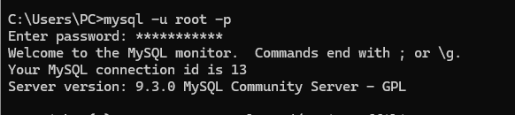

If not, you need to install and configure MySQL server properly.
https://dev.mysql.com/doc/refman/8.4/en/windows-installation.html

Q1 - Create the database and the table of articles

- Open the terminal and launch MySQL monitor:
mysql -u root -p

- Create a new database (e.g. week6Db) using the command line
- Create a new table (articles) with the columns below:

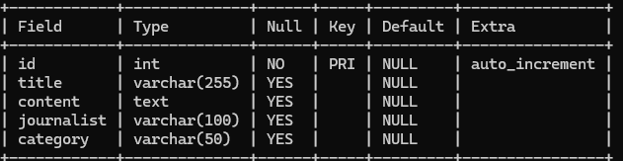

Q2 - Review My SQL queries
- Complete the bellow table with the appropriate MySQL query

Use case | My SQL Query
Get all articles | SELECT * FROM articles
Get articles written by the journalist ‘RONAN” | YOUR ANSWER
Add an article | YOUR ANSWER
Delete all articles whose title starts with “R” | YOUR ANSWER

EXERCISE 2 – MySQL on Backend
For this exercise, you start with a start frontend and a backend code.
The goal for this exercise is to replace the provided mock repository with a MySQL repository.

Q1 - Run Frontend & Backend

Open a dedicated terminal to run the server:
cd back
npm i
npm run dev

Open a dedicated terminal to run the client:
cd front
npm i
npm run dev

Open the browser and check the front end is correctly connected with the back end :

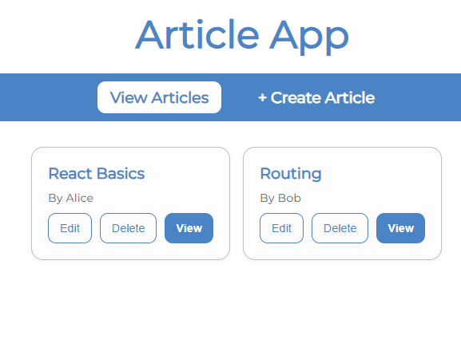

The project already works as we provide fake data (mock repository).
Let’s understand in detail the back and front ends.

FRONT-END

Q2 - Look at ArticleForm

How does the component know whether to create a new article or update an existing one?
YOUR ANSWER It receives the isEdit prop. If isEdit={true}, it updates; if isEdit={false}, it creates.

Why is the useParams hook used in this component? What value does it provide when isEdit is true?
YOUR ANSWER To extract the :id from the URL (e.g. /articles/3/edit). When isEdit is true, that id is used to fetch the existing article.

Explain what happens inside the useEffect hook. When does it run, and what is its purpose?
YOUR ANSWER It runs once when the component mounts. If isEdit is true and an id exists, it calls fetchArticle(id) to pre-fill the form with the existing article data.

Q3 - Look at the ArticleList

How are the three promise states (loading, success, and error) handled in the fetchArticles function?
YOUR ANSWER
setIsLoading(true) at the start
setError("") clears any previous error
On success: setArticles(data)
On failure (catch): setError("Failed to load articles...")
finally: setIsLoading(false) always runs

What is the role of the ArticleCard component, how does it communicate with the parent ArticleList?
YOUR ANSWER It is a presentational/child component that receives one article and three callback functions (onView, onEdit, onDelete) as props. It renders the card UI and calls the parent's functions when buttons are clicked.

BACK-END

Q4 - Why 3 layers ?
The backend is composed of the below 3 layers : routes, controllers and repository :

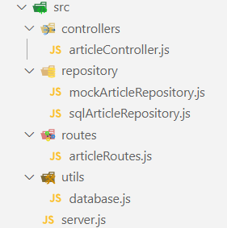

Describe the responsibility of each layer by completing the table below:

LAYTER | RESPONSABILITIES
Routes | YOUR ANSWER Defines URL paths and HTTP methods, maps them to controller functions
Controller | YOUR ANSWER Handles the HTTP request/response logic, calls the repository, returns JSON
Repository | YOUR ANSWER Executes SQL queries directly against the database, returns raw data

Q5 - Implement the database connection

Here are the files you need to update to connect the backend to the database:
FILE | RESPONSABILITIES
/.env | securely store your MySQL database credentials
/utils/ database.js | Holds the MySQL connection setup logic  Responsible for creating and exporting a connection pool that other parts of the application can use.
/repository/sqlArticleRepository.js | Provides a clean, reusable interface to interact with the articles table in your MySQL database.  Encapsulates all the SQL queries related to articles and exposes them as functions that the rest of your application can call.

Here is what you need to do:

- .env file
Create a .env file to securely store your MySQL database credentials.
See https://www.npmjs.com/package/dotenv

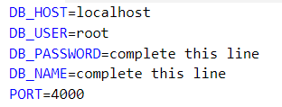

- utils/database.js
  - Create a MySQL connection pool using the credentials from the .env file.
https://sidorares.github.io/node-mysql2/docs#using-connection-pools

  - Export this connection pool so it can be used by other modules in the project.

- repositories/sqlArticleRepository.js

Implement the following functions to interact with the articles table in the database:
getAll() — fetch all articles
getById(id) — fetch one article by ID
create(article) — insert a new article
update(id, article) — update an existing article
remove(id) — delete an article by ID

Use the connection pool from database.js to execute the SQL queries inside these functions.

As an example, to implement getAll() :
export async function getArticles() {
const [rows] = await pool.query("SELECT * FROM articles");
return rows;
}

Q6 - Test the endpoints

To test the implementation of MySQL repository (create, update, remove, get articles…)
- First, perform tests using a REST API client (thunder or postman)
- Then, run the front-end project and asset the views work properly

EXERCISE 3 – Handle Journalists
For this exercise, you continue on the previous exercise code.

Now, users want to see who wrote each article to better understand the source.
- You will need to update the app, so the article page shows the journalist’s name and info.
- You will need to provide a journalist view, showing all articles written by a specific journalist.

Database
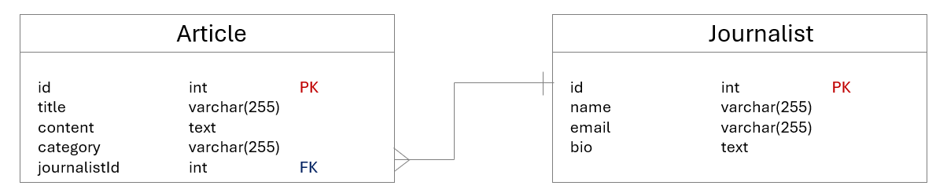
Update your database structure to handle the journalist table

- Create journalists table with fields: id, name, email, bi
- Update articles table to include journalist_id foreign key
- Populate the database with some fake data

Back End
- Implement repository methods:
  - Fetch articles with joined journalist name (using SQL JOIN)
  - Fetch all articles written by a specific journalist name (using SQL JOIN)

- Add controller functions:
  - Get all articles by journalist ID

- Define new API routes:
  - GET /api/articles/:id article + journalist name.
  - GET /api/journalists/:id/articles articles list by journalist.

Front End
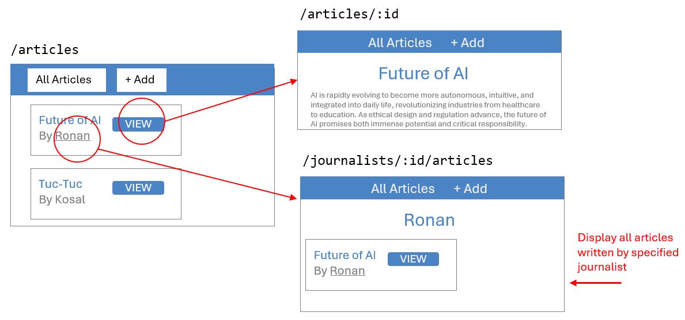
An additional view shall display all articles written by the specific journalist

- Update Article Details page:
  - Display journalist name alongside the article.
- Create Journalist Articles List page:
  - Display all articles by selected journalist.
- Add navigation:
  - From Article Details page, allow users to click journalist name to view that journalist’s articles.
- Update API calls:
  - Fetch combined article + journalist data.
  - Fetch articles filtered by journalist ID.

EXERCISE 4 – Handle Tags BONUS
For this exercise, you continue on the previous exercise code.

Now, users want to easily assign tags to articles.
The users can then filter articles by selecting different tags.

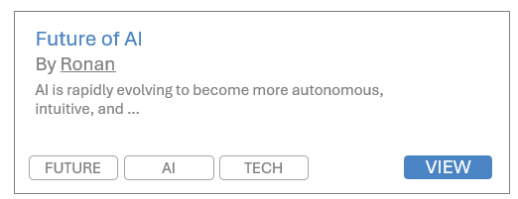

You will need to add categories to articles and let users filter the article list by selecting a category.

Database
- Create a new table Category (id, name).
  - What kind of relationships do we have between articles and categories?

Back End:
- Implement repository methods to:
  - Retrieve all categories.
  - Retrieve all articles filtered by category, using JOIN to include category name.
- Add a new API endpoint to get articles by category ID.

Front End:
- Add a multiple categories filter UI component on the article list page (multiple choice dropdown, chipset selector).
- When categories are selected, fetch and display only articles in those categories.
- Display categories names alongside articles in the list.

